

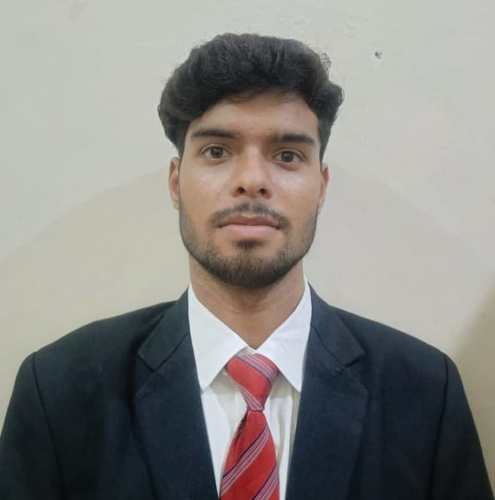

SAGAR KUMAR

Vill-Harli,P.O-Lodipur,Dist.-Gaya,Bihar,823003

+91 9135269430

2237709.cse.cec@cgc.edu.in

https://www.linkedin.com/in/sagar-singh-82b881245/

PROFESSIONAL SUMMARY

As a fresher, I am eager to further my skills and knowledge in software development and am enthusiastic about exploring new opportunities and challenges in the field. My experience and participation in various events showcase my passion for programming and problem-solving. I have experience creating a Quiz website and developing a Bank Management System.

TECHNICAL COMPETENCIES

**OS:** Windows

**Languages:** C |C++ | Core Java | Python | HTML | CSS | JavaScript

**Databases:** MS Access, MySQL

INTERPERSONAL SKILLS

Team Leadership | Management & Coordination | Decision Making & Analytical Skills | Growth Mindset

INTERESTS & HOBBIES

Travelling|Reading|Writing|Tech Enthusiast

LANGUAGES KNOWN

English | Hindi |

PERSONAL DETAILS

Mother’s Name: Malti Devi

Father’s Name: Sunil Singh

D.O.B: 01/02/2003

EDUCATION

Bachelors of Technology in Computer Science Engineering | Chandigarh Group of Colleges, Landran

Session: 2022-2025 | Score: 7.50 CGPA

Diploma (SBTE) | Govt. Polytechnic Buxar,Bihar

Session: 2018-2021 | Score: 7.95 CGPA

Matriculation (CBSE)| British English School,Manpur,Gaya,Bihar

Session: 2017-2018 | Percentage: 81.40%

TRAINING & PROJECTS

**Quiz Website | Developer**

Duration: 1 Month

Environment: Windows

Languages/Database: Html,Css,Javascript

Team Size: 2

* It is a Quiz website which has multiple choice questions. The Difficulty level of the question goes on increasing with the correct response.

**Bank Management System| Developer**

Duration: 15 Days

Environment: Windows

Languages/Database: C,C++

Team Size: Individual

* It is a desktop application a computerized telecommunications device that provides the customers of a financial institution with access to financial transactions in a public space without the need for a human clerk or bank taller

ACADEMIC ACHIEVEMENTS

* Participated in IT Day Hackathon Rajasthan.
* Participated in Walmart Hackathon.
* Participated in Coding Contest.

CERTIFICATIONS

* AWS Certification.
* Red Hat Training and Certification.
* Web Development from Excellence Technology.

EXTRA CURRICULAR & CO-CURRICULAR ACHIEVEMENTS

* Winner of 100metres race in Intercollege Competition.
* Organized events related to singing and dancing in 2022.
* Worked as a content writer in literary club of the college.